4.3.4 Searching Algorithms Problem Set Answer Sheet

This problem set requires you to use the skeleton program called Exercise 1. This is shown below and will be attached to the assignment post.

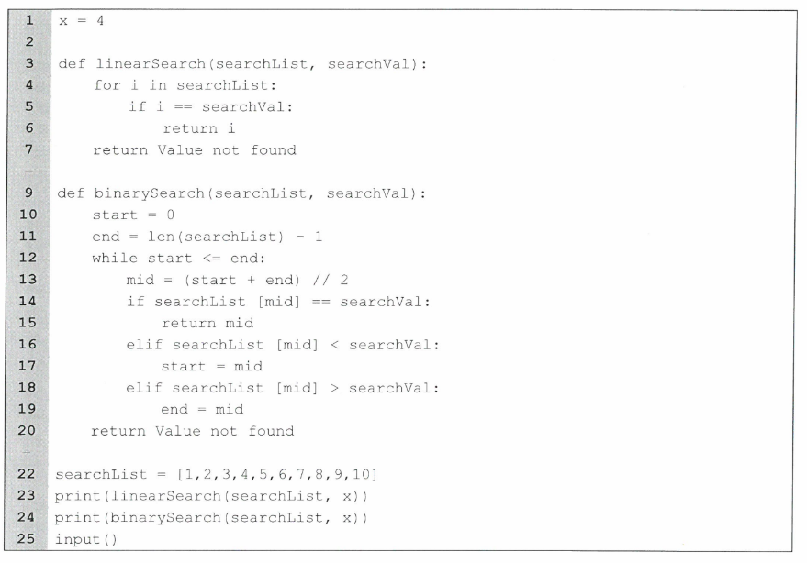

Instructions

This document is to be used as an answer sheet for the questions in the attached pdf file. This answer sheet has been designed to look similar to the AQA answer sheet used in the Paper 1 examination.

You will need to type or paste in screenshots/ screen captures of your code for the appropriate questions. For the questions with written answers you will need to type them in the appropriate space.

To hand in the work you will need to print off the work single sided and make sure your name is in the header part of the answer sheet.

Summary

Q | A1 | A2 | A3 | A4 | A5 | A6 | A7 | A8 | A9 | A10 | B1 | B2 | B3 | B4 | B5 | B6 | B7
Y
T | 1 | 1 | 1 | 1 | 1 | 1 | 2 | 2 | 2 | 2 | 1 | 1 | 1 | 5 | 4 | 2 | 5
Section A

Q No. | Answer | Your mark | Total mark
A1 | 3 |  | 1
A2 | 1 |  | 1
A3 | Binary |  | 1
A4 | If the list is not sorted it cannot be searched with binary search |  | 1
A5 | Value not found should be a string |  | 1
A6 | It compares the index to the value to look for and not the value at the index |  | 1
A7 | The end should be moved to midopoint-1 not just midpoint otherwise the value will never be selected |  | 2
A8 | The amount of operations requierd to complete the algorithm with a list of n items |  | 2
A9 | Liniar search = O(n), Binary search = O(log₂n) |  | 2
A10 | Using recursion can casue large memory usage when searching large lists |  | 2

Section B starts on the next page.

Section B

Q No. | Answer | Your mark | Total mark
B1 | x = 4  def linearSearch(searchList, searchVal):  for i in searchList:  if i == searchVal:  return i  return "Value not found"  def binarySearch(searchList, searchVal):  start = 0  end = len(searchList) - 1  while start <= end:  mid = (start + end) // 2  if searchList[mid] == searchVal:  return mid  elif searchList[mid] < searchVal:  start = mid  elif searchList[mid] > searchVal:  end = mid  return "Value not found"  searchList = [1,2,3,4,5,6,7,8,9,10]  print(linearSearch(searchList, x))  print(binarySearch(searchList, x)) |  | 1
B2 | def linearSearch(searchList, searchVal):  for i in searchList:  if searchList[i] == searchVal:  return i  return "Value not found" |  | 1
B3 | def binarySearch(searchList, searchVal):  start = 0  end = len(searchList) - 1  while start <= end:  mid = ((start + end) // 2)  if searchList[mid] == searchVal:  return mid  elif searchList[mid] < searchVal:  start = mid+1  elif searchList[mid] > searchVal:  end = mid-1  return "Value not found" |  | 1
B4 | def recursiveBinarySearch(searchList,searchVal, low=0, high=None):  if high is None:  high = len(searchList)-1  if high >= low:  mid = low + (high - low) // 2  if searchList[mid] == searchVal:  return mid  elif searchList[mid] > searchVal:  return recursiveBinarySearch(searchList, searchVal ,low, mid-1)  else:  return recursiveBinarySearch(searchList, searchVal, mid + 1, high)  else:  return "Value Not Found" |  | 5
B5 | def getVal() -> int | None:  try:  val = int(input("Enter a value: "))  return val  except Exception:  print("Not accepted")  return None |  | 4
B6 | def generateList(val = None):  while val is None:  val = getVal()  userlist = [i for i in range(val)]  return userlist |  | 2
B7 | def test(n, tests):  searchList = generateList(n)  resultsBinary = 0  resultsLinear = 0  for i in range(tests):  resultsBinary += BinarySearch(searchList, i)  resultsLinear += linearSearch(searchList, i)  averageBinary = (resultsBinary / tests) * 100  averageLinear = (resultsLinear / tests) * 100  print(f"Average binary search length: {averageBinary}")  print(f"Average linea |  | 5

This is the end of the answer sheet.
Check that the printouts are readable.
Crop screen captures appropriately.
Make sure you print it off single sided and your name in the header of every page.

